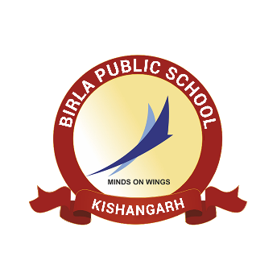**BIRLA PUBLIC SCHOOL, KISHANGARH**

**APTITUDE TEST (2025-26)**

**GRADE IX**

**SYLLABUS**

|  |  |  |
| --- | --- | --- |
| **Class** | **Subject** | **Syllabus** |
| **Grade IX** | English | **Reading Comprehension**  **Writing Skill:** Story Writing  **Grammar –** (a) Editing (Tense)  (b) Active and Passive |
| Mathematics | 1. Rational Numbers 2. Linear Equations in One Variable 3. Understanding Quadrilaterals 4. Squares And Square Roots 5. Mensuration (Area and Perimeter, Surface area and volume of cube, cuboid and cylinder) |
| Biology | 1. Crop Production and management 2. Microorganisms: Friend or Foe |