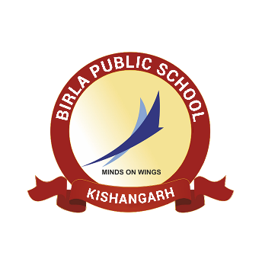**BIRLA PUBLIC SCHOOL, KISHANGARH**

**APTITUDE TEST (2025-26)**

**GRADE VII**

**SYLLABUS**

|  |  |  |
| --- | --- | --- |
| **Class** | **Subject** | **Syllabus** |
| **Grade VII** | English | 1. Reading Comprehension - Unseen passage 2. Grammar - The Sentence, Subject/ Predicate, Nouns, Adjectives and Degrees, Antonyms and Synonyms 3. Paragraph Writing and Letter Writing |
| Mathematics | 1. Number system 2. Lines and Angles 3. Factors and Multiples |
| Science | 1. Mindful Eating: A Path to a Healthy Body 2. Materials Around Us 3. Methods of Separation in Everyday Life |