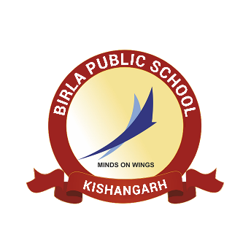**BIRLA PUBLIC SCHOOL, KISHANGARH**

**APTITUDE TEST (2025-26)**

**GRADE VIII**

**SYLLABUS**

|  |  |  |
| --- | --- | --- |
| **Class** | **Subject** | **Syllabus** |
| **Grade VIII** | English | 1. Reading Comprehension - Unseen passage 2. Grammar - The Sentence, Verbs, tenses 3. Paragraph Writing, Letter Writing and Notice Writing |
| Mathematics | 1. Integers 2. Fraction and Decimals 3. Data Handling |
| Science | 1. Nutrition in plants and animals 2. Heat 3. Physical and Chemical changes |