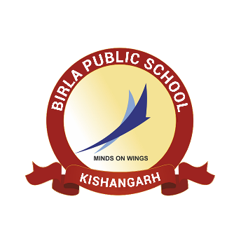**BIRLA PUBLIC SCHOOL, KISHANGARH**

**APTITUDE TEST (2025-26)**

**GRADE X**

**SYLLABUS**

|  |  |  |
| --- | --- | --- |
| **Class** | **Subject** | **Syllabus** |
| **Grade X** | English | **Reading Comprehension**  **Writing Skills**  Informal letter  **Grammar –** (a) Editing or omission  (b) Reordering of words |
| Mathematics | 1. Number System 2. Polynomials 3. Co-Ordinate Geometry 4. Linear Equations in Two Variables 5. Lines and Angles 6. Triangles 7. Heron's Formula 8. Surface area and volume 9. Statistics |
| Biology | 1. Cell: Structure and functions 2. Tissue: Plant and animal tissue |