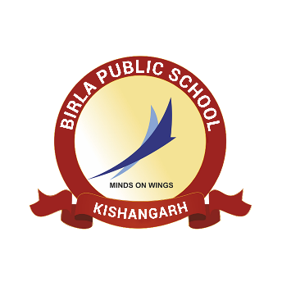**BIRLA PUBLIC SCHOOL, KISHANGARH**

**APTITUDE TEST (2025-26)**

**GRADE XI**

**SYLLABUS**

|  |  |  |
| --- | --- | --- |
| **Class** | **Subject** | **Syllabus** |
| **Grade XI** | English | **Reading Comprehension**  **Writing Skills**   1. Letter to the Editor   **Grammar**   1. Editing – Error and omission 2. Reordering of words |
| Mathematics | 1. Real numbers 2. Polynomials 3. Pair of linear equations in two variables 4. Quadratic Equations 5. Arithmetic Progressions 6. Triangles 7. Coordinate geometry 8. Trigonometry |
| Biology | 1. Life processes 2. Heredity 3. Control and coordination |
| Chemistry | 1. Chemical reactions and equations 2. Acids, bases and salts |
| Physics | 1. Electricity 2. Magnetic Effects of Electric Current. |